**LAB # 07**

***Introduction to HTML (Basic Concept, Code and Syntax)***



**Fall 2022**

# ***CSE101L Computer Fundamentals Lab***

Submitted by: **Haris Khan**

Registration No. : **60032**

Class Section: **A**

“On my honor, as student of University of Engineering and Technology, I have neither given nor received unauthorized assistance on this academic work.”

Student Signature: ______________

Submitted to:

**Engr. Abdullah Hamid**

December 22, 2022

Department of Computer Systems Engineering

University of Engineering and Technology, Peshawar

***Step#01:***

In the first step, I coded in HTML for my topic present below in the screen shot.

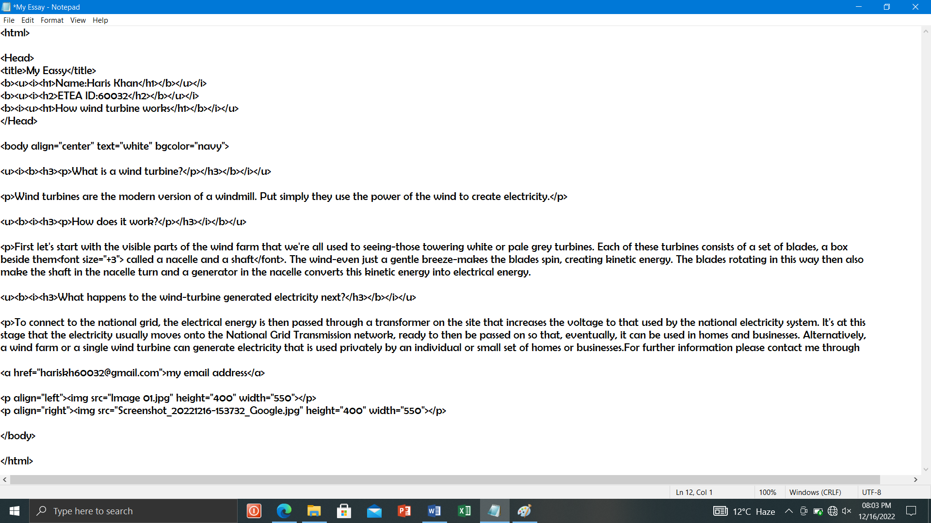

Step#02:

In the second step after completing coding of HTML, I saved it and ran in Microsoft Edge

